What is the Chordia U16?

The U16 is the simplest way to
- Connect multiple instruments, mixers, singers, or speakers via a single USB device to your tablet, laptop or PC.
- Make sure that what gets played, spoken or sung can be recorded in synch, without delay, by your computer or tablet.
- Expand the extremely limited options for audio capture and playback to accommodate as many sound sources as you might need.
- Ensure that if you do run out of inputs, you can add a second or third U16 to provide even more*
- Make it easy to move around. The U16 is a tiny, light and efficient device that is powered by its USB host (your computer or tablet)
- Future-proof your investment in recording equipment. The U16 works without requiring any extra drivers or control software. Nothing to install or update when you buy a new machine or change operating system.
Perhaps it comes as a surprise that there is no easy way to do this already. After all, you can plug a headset or microphone into your laptop or PC.

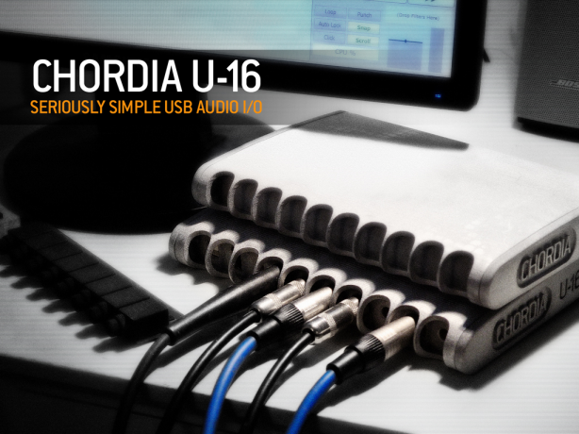

How?

At the simplest level the U16 plugs into a USB port on the computer or tablet of your choice. Once you start running your recording software, sounds from any suitable instrument or microphone will be captured by the U16 and sent to the software for processing and storage. Using the recording software you can mix all of your sound sources to two channels (stereo) and also use the U16 to listen to your recorded material at the highest possible quality. Here are 3 scenarios which illustrate precisely how things are connected:

Scenario #1: Recording the band.

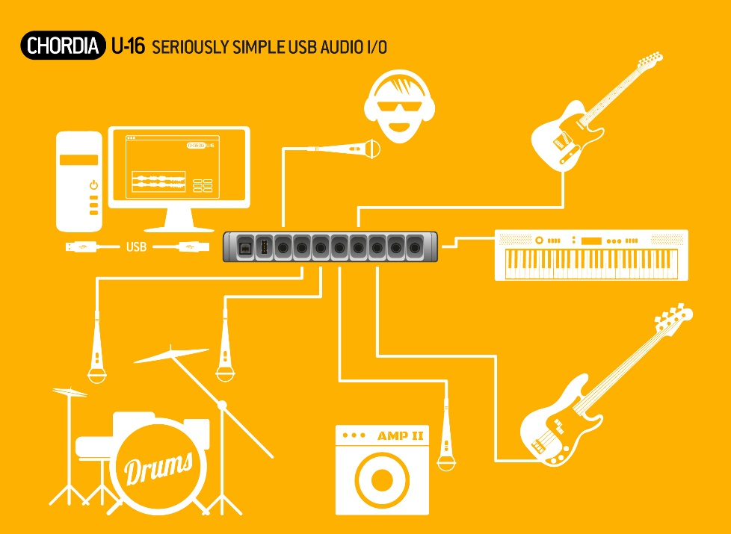

Scenario #2: Recording the band (the extended mix).

#2 is really simple filler with 2 units, the second being all mikes for some backing singers/brass. Just to illustrate extensibility

Scenario #3: The Film Score.

#3 is to try and drive home that even a single composer/producer/engineer can benefit. The person in question is operating solo and does not want to keep unplugging/replugging/setting levels etc. as movie scoring advances. Once all is rigged it is time to get creative. No interruptions, no aggravation, no excuses. 

The (technical) details

A little more detail about the tech spec for the Chordia U16. Although we are really serious about the technology that goes inside the U16, we are even more serious about keeping it all simple. So this section is optional. If you care about dB measurements, latency timings in microseconds and other such numbers then please read on.
Headline numbers:
Sample Rates: 48 and 96 KHz.
Bit depths: 16 and 24 bits
Instrument inputs are very high impedance (+10M) for guitars and basses
Line level inputs are low impedance (NN dB @ +/-2.2V RMS)
Sound to noise ratio on inputs: +103dB
What is in the box?
The engine is a gigahertz class ARM processor linked to a set of Wolfson audio codecs via some custom logic. There is plenty of FLASH storage and lots of SDRAM as well to ensure that the U16 can (and will) be updated with new on-board software as we continue to expand the software capabilities. Keep an eye on our stretch goals. Oh. And yes, it does run Linux as well.
The audio connectors are all top-quality Neutriks. What else can we say?
The U16 has guaranteed driver-free box compatibility with Windows, OSX, iPad and Android tablets.
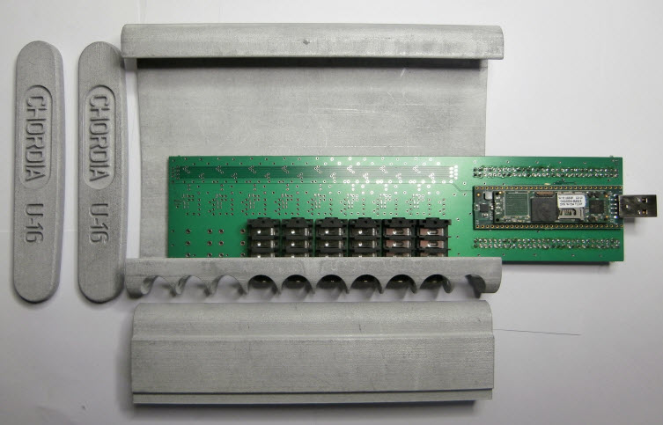

Aggregation?

This is our buzzword for ‘let’s replace many cables and a USB hub with something simpler and smarter’. In other words what the U16 can do is connect to another USB audio source, like a microphone, Bluetooth dongle or *another* U16 and make them look like one device. Subject to power constraints (and see our stretch goals for a bit of joined-up thinking here) you can plug in as many USB units as your host device can handle. When we say ‘host’ here it means your PC, laptop or tablet.
But, wait. There is more. This is not the end of the story by any means. The pretty much unique aspect to aggregation is that it makes many devices look like one to your recording software. And, as most recording software can only record from one device at a time, we think that this counts as a really significant innovation. When you want to record 24 tracks of audio, plug in another U16 and your recording workstation software (DAW) will understand what is going on.
Why is the project on KickStarter?

We’ve spent a hard 12 months on the project to date. We want to refine and validate our ideas moving forward into production. But we want more resources to be able to do this absolutely right. Here are some of the things we need to do:
      - Get an identity from the USB consortium.
      - Get EMC/FCC accreditation for selling in both the EU and the US
      - Get production tooling made for the U16’s aluminium casing.
      - Establish a retail pipeline to start building our next set of designs.

When?

We estimate that U16 deliveries will be made to early adopters in November 2014. Our timeline breakdown for achieving this goal starts at the end of our KickStarter campaign:
Week 1: Finalize design drawings for the tooling for the aluminium cases
Week 2: Finalize Kickstarter packaging design (extremely environmentally friendly)
Week 3: Finalize the design for the printed circuit board (PCB)
Week 4: Place order for aluminium tooling
Week 5: Verify PCB for electrical and mechanical compliance.
Week 7: Place orders for PCB’s. Verify tooling for cases.
Week 8: Place orders for cases.
Week 10: Component logistics. Place order with suppliers for electronic components. Staging will ultimately vary with the final number of Kickstarter pledges.
Week 10: Receipt of PCB’s for initial electronic assembly
Week 11: Receipt of cases. Start of mechanical assembly and integration of PCB’s.
Week 13: Review of any lessons learnt from electrical and mechanical assembly. Revise any impacted designs if required. We would expect to be commencing the full production run for subsequent Kickstarter pledges at this point in time.
Week 16: Packaging and dispatch of units for KickStarter early adopters
Development of the U16 began in the middle of 2013. We have spent the last 12 months working on the electronic, mechanical and software aspects of the project. 3D printed cases were first delivered in late 2013 along with printed circuit boards carrying both connectors and converter devices. A revised digital interface for connecting analogue electronics to the processor board was prototyped in May 2014. The processor design itself is based on an existing, in production, open source design which has not required any prototype integration.

Who?

Jerry Evans. Software
Richard Aras. Hardware
Vishay Moghan. Creative imaging.

Pledges

- £35. Get the U16 shirt. Not just any old T-shirt, but, a beautifully tailored and classy Rugby/Polo/Whatever top.
- £159 x200. Early adopter rights. Get a unit early and from the first hand-built production run.
- £175 x500. Production units. To be shipped within 4 weeks of the fulfilment to early adopters.
- £499 x5. Custom Finishes. You specify the finish and any engraving you would like to have on your U16 case. This can be as discrete as you like or as outrageous. We are limited by the finishes that can be applied to aluminium. Gold plating is therefore *not* on the menu.
- £1999 x1. A single custom unit. We will build you a device that meets your exact specifications, with options including the number of inputs and outputs, types of connector (1/4”, XLR, RCA) and expansion of the unit up to a maximum of 24 input channels. Finish and color of your choice. We’ll autograph the inside and send you a presentational video as well. N.B. Terms and conditions apply.

Stretch Goals

Well. We are not short of ideas. And some of them are based on exploiting the full potential of our embedded DSP and networking stack. In other words, there is a boatload of really cool stuff we can do to extend the capabilities of the U16. But before we explore that really good space here are some initial stretches.
- (£50000) Unlock the remote potential with an Apple iOs/Android control app for phones and tablets
- (£75000) Massively increase your portability with the U16 LiOn battery pack.
- (£100000) Enable Wireless networking in the U16. Be able to control the unit via Bluetooth or WiFi.
- More. All pretty much software based.

